

**Civil and Environmental Engineering Department Seminar  
& Case Advancement Fellows**

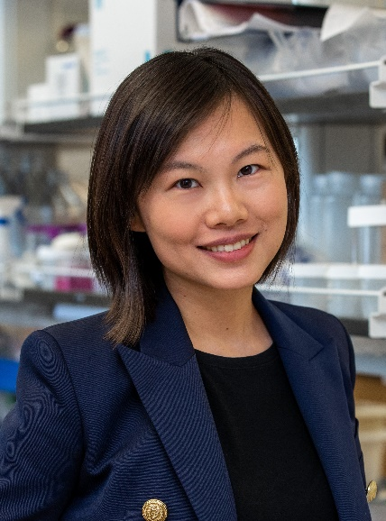 **Dr. Flanging Ling**

Assistant Professor

Department of Energy, Environmental and

Chemical Engineering

Washington University

**Date**: Thursday, April 10, 2025

**Time**: 4:00pm – 5:00pm EST

**Location**: Vose, Room 138

**VIA ZOOM** [**HERE**](https://cwru.zoom.us/j/93460065868?pwd=ZzZFVUhldkZtRWNuaWQvQXdmbW1rQT09)

***Utilizing Microbes as Biosensors of the Urban Environment***

**Abstract:** The microbes inhabiting urban environments present long-overlooked sources of information about infrastructure status, human health, and ecosystem health. Advances in NextGen DNA sequencing technology have enabled the rapid acquisition of large volumes of genomic data from urban environments, however, adequate methods for sampling, modeling, and data analysis are required to gain insights useful for engineering applications. In this presentation, we will discuss efforts utilizing microbes in sewage and drinking water to monitor public health and the water pipelines. We will also discuss efforts to explore microbiomes as resources to expand the conservation biology toolset at the boundary of built and natural environments. Taken together, these studies show that understanding generalizable and system-specific determinants of bacterial communities will create new ways for improving engineering design and urban environments.

**Bio**: Flanging Ling is an Assistant Professor at the Department of Energy, Environmental and Chemical Engineering at Washington University in St. Louis. At WashU, she is leading a research group that explores the fundamental principles behind the assembly of microbial communities in urban environments, combining fieldwork, experiments, and computational methods to understand how microbes interact with urban environmental conditions. The Ling Lab aims to inform engineering solutions that improve urban infrastructure, public health, and sustainability. Ultimately, they aim to translate this knowledge into practical applications that can help create healthier, more resilient cities.

Dr. Ling earned her Ph.D. degree from the University of Illinois at Urbana-Champaign in 2016. During her Ph.D., she worked with Dr. Wen-Tso Liu to study the microbiology of drinking water distribution systems. Before starting her faculty position at WashU, she completed an Alfred Sloan Foundation Microbiology of the Built Environment Postdoctoral Fellowship at the Massachusetts Institute of Technology. Dr. Ling has received accolades such as the National Science Foundation CAREER award, ISME/IWA BioCluster Rising Star, and the ACS Environmental Au Rising Star.