Civil and Environmental Engineering
Department Seminar
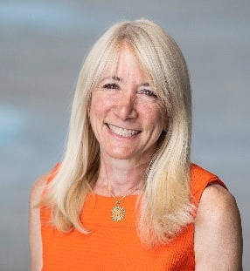
Dr. Elise Miller-Hooks
Professor & Hazel Chair in Infrastructure Engineering Interim Department Chair, Department of Civil,
Environmental, and Infrastructure Engineering
George Mason University
Date: Friday, November 10th, 2023
Time: 12:45pm – 2:00pm EST
Location: Bingham Bldg., Room 140

Constructs in infrastructure resilience framing: From components to community services and the built and human infrastructures on which they rely

Abstract: Underlying many infrastructure component and system resilience studies is an implicit construct for framing resilience. This talk explores how this construct affects and enables resilience understanding. To this end, five constructs for framing infrastructure resilience estimation will be presented. These constructs range from the consideration of a single component to a community service provided through a set of buildings whose functionality relies on interdependent supporting lifelines. The value of reframing the resilience computation around services that are provided by built environments rather than around the built systems themselves will be explored. Taking a service-based viewpoint induces a change in perspective with rippling impact. It impacts the quantification methods needed and affects the choice of metrics for measuring resilience, adaptation strategies to include in assessment, baselines for comparison, and elements of the built environment to incorporate in the evaluation. It necessitates consideration of humans as infrastrcuture and other socio-technical concerns. It also brings hidden issues of inequity to the foreground.

Bio: Dr. Elise Miller-Hooks holds the Bill and Eleanor Hazel Endowed Chair in Infrastructure Engineering and is the Interim Department Chair of the Sid & Reva Dewberry Department of Civil, Environmental, and Infrastrucure Engineering at George Mason University. She has served as an advisor to the World Bank Group and is the founding Editor-in-Chief of Elsevier’s Sustainability Analytics and Modeling journal. Prior to her appointment at Mason, Dr. Miller-Hooks served as a program director at the U.S. National Science Foundation and on the faculties of the University of Maryland, Pennsylvania State University and Duke University. Dr. Miller-Hooks received her Ph.D. (1997) and M.S. (1994) degrees in Civil Engineering from the University of Texas – Austin and B.S. in Civil Engineering from Lafayette College (1992).

